Ministerul Educaţiei al Republicii Moldova

Universitatea Tehnică a Moldovei
Facultatea: Calculatoare, Informatică şi Microelectronică

Raport

Lucrare de laborator Nr:7

Disciplina: Programarea Calculatoarelor

Tema: ____________________________________
Varianta nr. 5

A efectuat st.gr. Brăduleac Vadim AI-151
A verificat L.Stadler

Chişinău
2015
Sarcina lucrării:
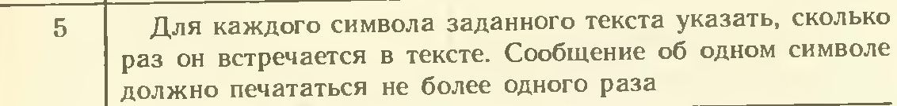

Schema Bloc:
START
c=j
stm[50],stm1,s1,I,j,c,n,sym126

s=0,n=0
sym[i]=sym[i]+1
i++
i=0,90
j=32
i=0,90
sym[i]=0
sym[i]!=0
sym[i]!=1
--------------
i=0,strlen(stm)

j,sym[i]

fputc(stm[i])
c=fgets(out)
sym i-1

i=0
j=32,122

j,sym[i]

STOP
LISTTINGUL PROGRAMULUI:
#include <stdio.h>
#include <string.h>
int main()
{
//Declararea
char stm[50];
int stm_l, s_l = 0, i, j, c, n = 0;
int sym[126];
for (i = 0; i <= 90; i++) sym[i] = 0;
//Citirea caracterelor
gets(stm);
printf("-----------\n");
FILE *In = fopen("c://mylog.txt", "w");
for (int i = 0; i < strlen(stm); i++){
fputc(stm[i],In);
}
fclose(In);
//Scrierea caracterelor
FILE *Out = fopen("c://mylog.txt","r");
do{
c = fgetc(Out);
for (i = 0, j = 32; j <= 122; i++, j++){
if (c == j)sym[i] = sym[i] + 1;
}
} while (c!=EOF);
fclose(Out);
//Afisarea
for (i = 0,j=32; i<90; i++, j++){
if (sym[i] != 0 && sym[i] !=1 ) printf("%c: de %d ori\n", j, sym[i]);
if (sym[i] == 1) printf("%c: o data\n", j, sym[i]);

}
printf("-----------");
//Finisarea
getchar();
}
Rezultatul programului:

